CHANGE LOG

3/21/2020 – DXF INITIAL RELEASE

3/21/2020 – UPDATED FOR REDUCED OUTER SHIELD THICKNESS

HOLDERFRAME_TOP_REV0 to HOLDERFRAME_TOP_REV1  
EmergencyFaceShield_ASM_REV0 to EmergencyFaceShield_ASM_REV1

Change description:

*Decreased slit width*, use thin outer sheet of plastic instead of 1/8”  
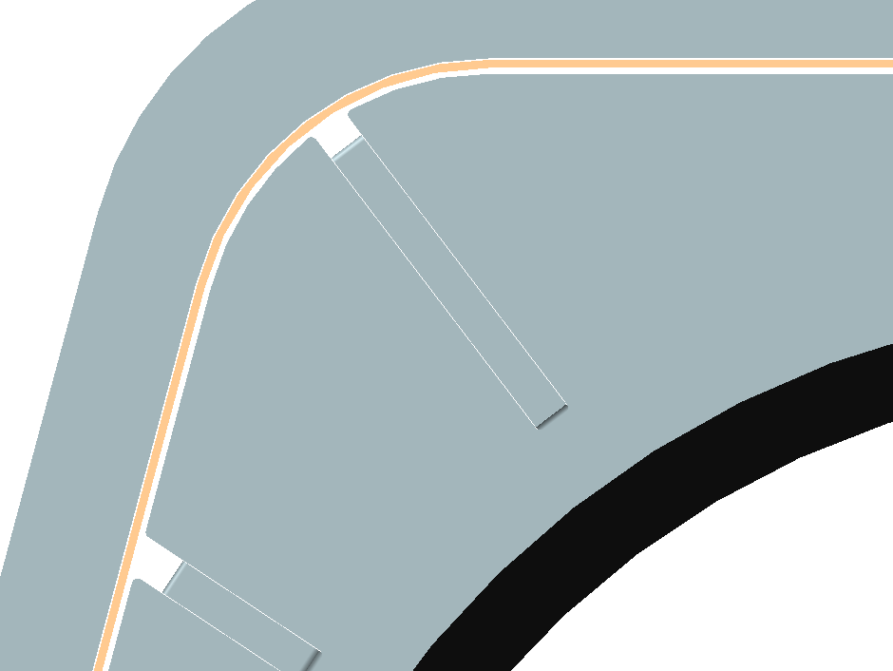  
  
*Add holes for cable tie in ASM step file*  
  
